**INDEX**

**VISUAL PROGRAMMING LAB**

**VC++**

|  |  |  |  |
| --- | --- | --- | --- |
| **S. No** | **Date** | **Program Description** | **Page No** |
| 01 |  | Drawing Circles at Mouse Click Points |  |
| 02 |  | Creating Message Map Implementation |  |
| 03 |  | Create Paint Window and Draw an Object |  |
| 04 |  | Animating an Object |  |
| 05 |  | List Box Application |  |

**VISUAL BASIC.NET**

|  |  |  |  |
| --- | --- | --- | --- |
| **S. No** | **Date** | **Program Description** | **Page No** |
| 06 |  | Font Applications |  |
| 07 |  | Calculator |  |
| 08 |  | Notepad Applications |  |
| 09 |  | Text File Creation |  |
| 10 |  | Newspaper Vendor Details |  |

**VC++DRAWING CIRCLES AT MOUSE CLICK POINTS**

**PROGRAM CODING:**

#include<afxwin.h>

class pgm1 : public CFrameWnd

{

public:

pgm1()

{

Create(0, "DRAWING CIRCLES");

}

void OnLButtonDown(UINT u, CPoint pt)

{

CClientDC d(this);

CBrush cb;

CPen cp;

cb.CreateSolidBrush(RGB(200, 500, 200));

cp.CreatePen(PS_SOLID, 4, RGB(50, 255, 0));

d.SelectObject(&cb);

d.SelectObject(&cp);

d.Ellipse(pt.x, pt.y, pt.x + 50, pt.y + 50);

}

DECLARE_MESSAGE_MAP()

};

BEGIN_MESSAGE_MAP(pgm1, CFrameWnd)

ON_WM_LBUTTONDOWN()

END_MESSAGE_MAP()

class mywindow : public CWinApp

{

public:

int InitInstance()

{

pgm1 *pg = new pgm1;

m_pMainWnd = pg;

pg->ShowWindow(1);

return 1;

}

};

mywindow mw;

**OUTPUT:**

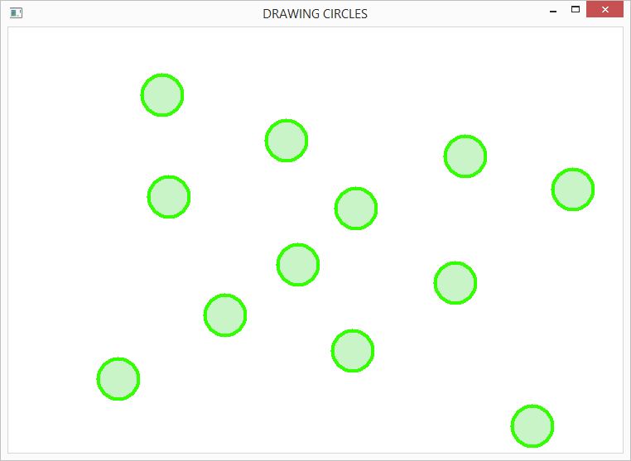

**CREATING MESSAGE MAP IMPLEMENTATION**

**PROGRAM CODING:**

#include<afxwin.h>

class pgm2 : public CFrameWnd

{

public:

pgm2()

{

Create(0, "IMPLEMENTING MESSAGE MAP");

}

void OnLButtonDown(UINT u, CPoint pt)

{

char msg[50];

sprintf_s(msg, "Left Button is pressed at (%d,%d)", pt.x, pt.y);

CClientDC d(this);

d.TextOut(pt.x, pt.y, msg);

MessageBox(msg, "Left Button is pressed");

}

void OnRButtonDown(UINT u, CPoint pt)

{

char msg[50];

sprintf_s(msg, "Right Button is pressed at (%d,%d)", pt.x, pt.y);

CClientDC d(this);

d.TextOut(pt.x, pt.y, msg);

}

DECLARE_MESSAGE_MAP()

};

BEGIN_MESSAGE_MAP(pgm2, CFrameWnd)

ON_WM_LBUTTONDOWN()

ON_WM_RBUTTONDOWN()

END_MESSAGE_MAP()

class mywindow : public CWinApp

{

public:

int InitInstance()

{

pgm2 *pg = new pgm2;

m_pMainWnd = pg;

pg->ShowWindow(1);

return 1;

}

};

mywindow mw;

**OUTPUT:**

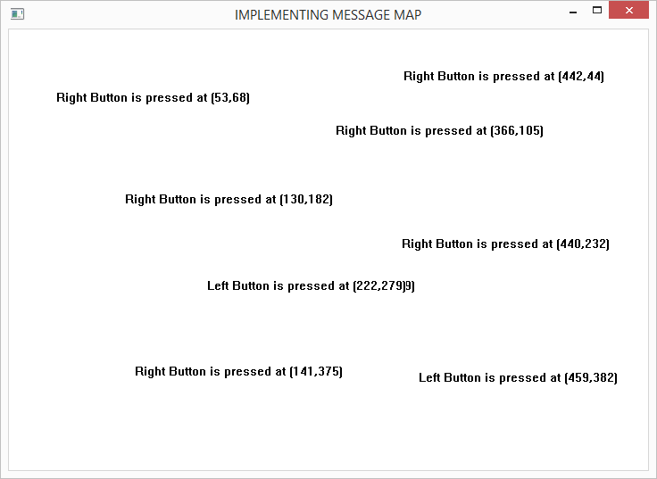

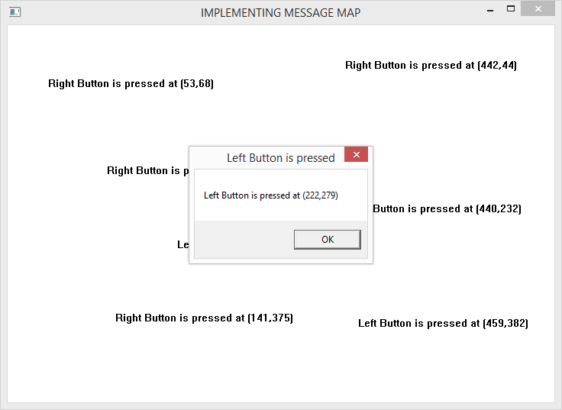

**CREATE PAINT WINDOW AND DRAW AN OBJECT**

**PROGRAM CODING:**

#include<afxwin.h>

class paintb : public CFrameWnd

{

CPoint m_StartPoint, m_EndPoint;

public:

paintb()

{

Create(NULL, "Drawing Line");

}

void OnLButtonDown(UINT nFlags, CPoint point);

void OnLButtonUp(UINT nFlags, CPoint point);

DECLARE_MESSAGE_MAP()

};

BEGIN_MESSAGE_MAP(paintb, CFrameWnd)

ON_WM_LBUTTONDOWN()

ON_WM_LBUTTONUP()

END_MESSAGE_MAP()

void paintb::OnLButtonDown(UINT nFlags, CPoint point)

{

CFrameWnd::OnLButtonDown(nFlags, point);

m_StartPoint = point;

}

void paintb::OnLButtonUp(UINT nFlags, CPoint point)

{

CFrameWnd::OnLButtonDown(nFlags, point);

m_EndPoint = point;

CClientDC dc(this);

dc.MoveTo(m_StartPoint);

dc.LineTo(m_EndPoint);

}

class Myapp :public CWinApp

{

public:

BOOL InitInstance()

{

m_pMainWnd = new paintb();

m_pMainWnd->ShowWindow(1);

return 1;

}

};

Myapp theapp;

**OUTPUT:**

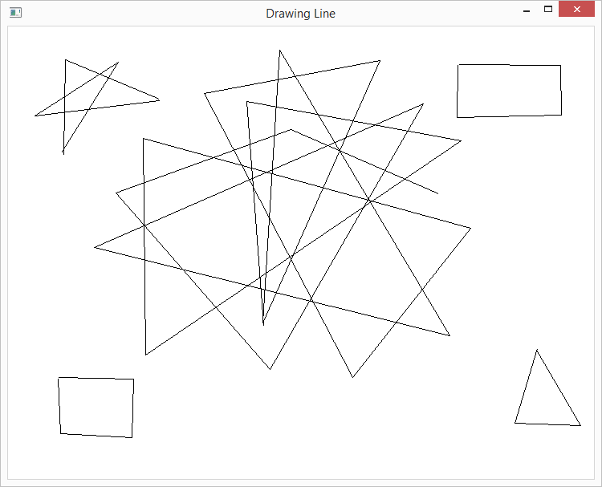

**ANIMATING AN OBJECT**

**PROGRAM CODING:**

#include<afxwin.h>

#include"resource.h"

class pgm4 : public CFrameWnd

{

int x;

public:

pgm4()

{

Create(0, "ANIMATION OF AN OBJECT");

SetTimer(1, 100, 0);

x = 0;

}

int OnEraseBkgnd(CDC *d)

{

CRect r;

GetClientRect(&r);

CBrush mybrush(RGB(255, 255, 255));

d->SelectObject(&mybrush);

d->FillRect(&r, &mybrush);

CDC c;

CBitmap mybitmap;

mybitmap.LoadBitmap(IDB_BITMAP1);

c.CreateCompatibleDC(d);

c.SelectObject(&mybitmap);

d->BitBlt(x, 100, 50, 50, &c, 0, 0, SRCCOPY);

x = x + 10;

if (x>1500)x = 0;

return 1;

}

void OnTimer(UINT_PTR)

{

Invalidate();

}

DECLARE_MESSAGE_MAP()

};

BEGIN_MESSAGE_MAP(pgm4, CFrameWnd)

ON_WM_ERASEBKGND()

ON_WM_TIMER()

END_MESSAGE_MAP()

class mywindow : public CWinApp

{

public:

int InitInstance()

{

pgm4*pg = new pgm4;

m_pMainWnd = pg;

pg->ShowWindow(3);

return 1;

}

};

mywindow mw;

**OUTPUT:**

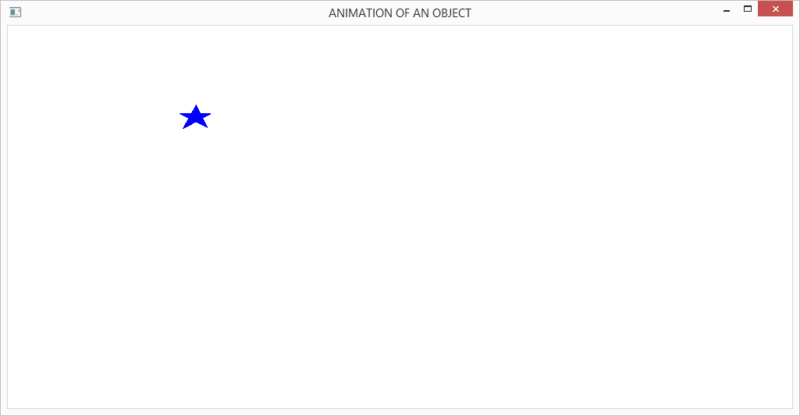

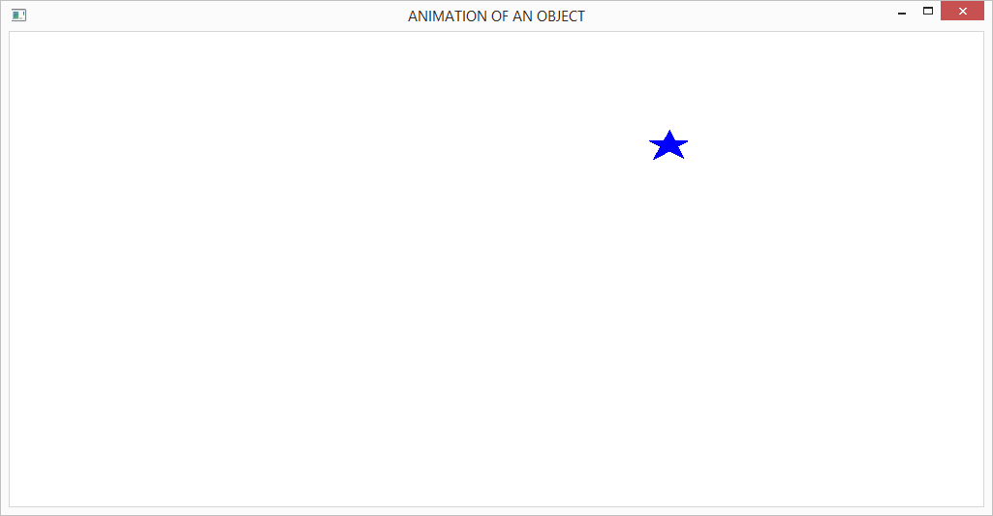

**LIST BOX APPLICATION**

**PROGRAM CODING:**

#include<afxwin.h>

class Mylistbox : public CFrameWnd

{

CListBox list;

CButton ins, del, cnt, res;

CEdit txt;

CString str;

public:

Mylistbox()

{

CString myclass;

myclass = AfxRegisterWndClass(CS_HREDRAW | CS_VREDRAW, 0, (HBRUSH)::GetStockObject(GRAY_BRUSH), 0);

Create(myclass, "List Box Applications");

}

int OnCreate(LPCREATESTRUCT lpCreateStruct)

{

CFrameWnd::OnCreate(lpCreateStruct);

txt.Create(WS_CHILD | WS_VISIBLE, CRect(100, 30, 300, 50), this, 9);

list.CreateEx(WS_EX_CLIENTEDGE, "LISTBOX", NULL, WS_CHILD | WS_VISIBLE | LBS_STANDARD,

CRect(100, 70, 350, 220), this, 1);

ins.Create("INSERT", WS_CHILD | WS_VISIBLE | BS_PUSHBUTTON, CRect(360, 70, 500, 95

), this, 2);

del.Create("DELETE", WS_CHILD | WS_VISIBLE | BS_PUSHBUTTON, CRect(360, 100, 500,

125), this, 3);

cnt.Create("COUNT", WS_CHILD | WS_VISIBLE | BS_PUSHBUTTON, CRect(360, 130, 500, 155), this

, 4);

res.Create("RESET", WS_CHILD | WS_VISIBLE | BS_PUSHBUTTON, CRect(360, 160, 500, 185), this,

5);

return 0;

}

void insertitems()

{

txt.GetWindowText(str);

int index = list.GetCurSel();

list.InsertString(index, str);

}

void deleteitems()

{

int index = list.GetCurSel();

list.DeleteString(index);

}

void countitems()

{

int max = list.GetCount();

char msg[80];

sprintf_s(msg, "%d Items are available in the listbox", max);

MessageBox(msg, "Count");

}

void resetitems()

{

list.ResetContent();

}

void selecteditem()

{

CString sitem;

int index = list.GetCurSel();

list.GetText(index, sitem);

sitem = "Item :" + sitem;

MessageBox(sitem, "is the Currently Selected item in listbox");

}

DECLARE_MESSAGE_MAP()

};

BEGIN_MESSAGE_MAP(Mylistbox, CFrameWnd)

ON_WM_CREATE()

ON_LBN_SELCHANGE(1, selecteditem)

ON_COMMAND(2, insertitems)

ON_COMMAND(3, deleteitems)

ON_COMMAND(4, countitems)

ON_COMMAND(5, resetitems)

END_MESSAGE_MAP()

class Myapp : public CWinApp

{

public:

int InitInstance()

{

Mylistbox*mlb = new Mylistbox;

mlb->ShowWindow(3);

m_pMainWnd = mlb;

return 1;

}

};

Myapp m;

**OUTPUT:**

**Insert**

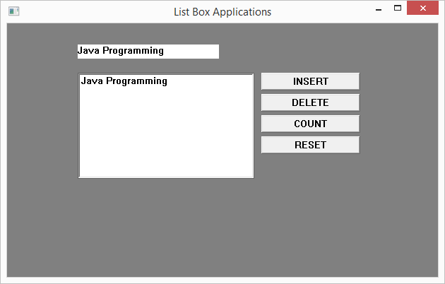

**Count**

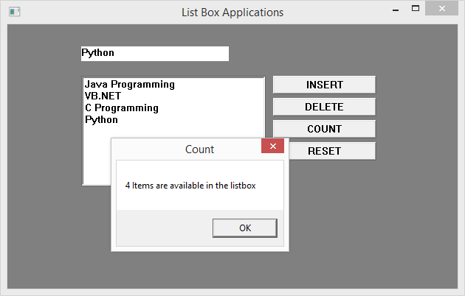

**Select**

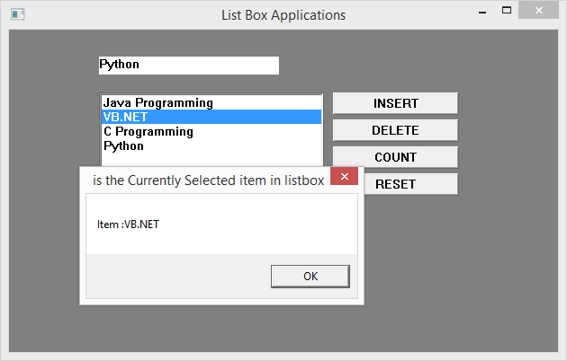

**Delete**

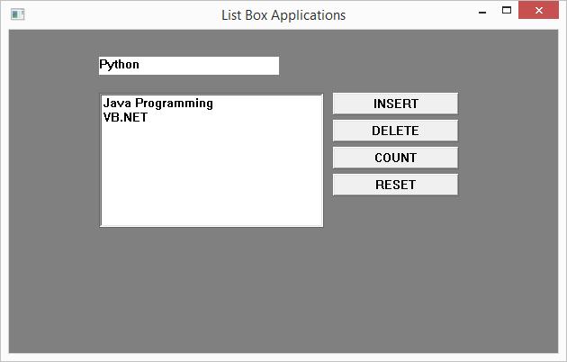

**Reset**

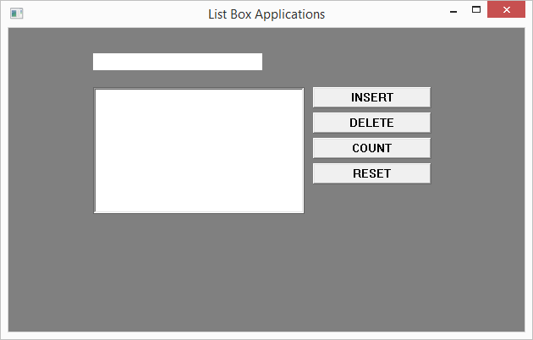

**VB.NET**

**FONT APPLICATIONS**

**PROGRAM CODING:**

Public Class Form1

Dim fd As New FontDialog

Dim cd As New ColorDialog

Private Sub Button1_Click(sender As Object, e As EventArgs) Handles Button1.Click

fd.ShowDialog()

Label2.Font = fd.Font()

Label2.AutoSize = True

End Sub

Private Sub Button2_Click(sender As Object, e As EventArgs) Handles Button2.Click

cd.ShowDialog()

Label2.ForeColor = cd.Color

End Sub

Private Sub Button3_Click(sender As Object, e As EventArgs) Handles Button3.Click

End

End Sub

End Class

**OUTPUT:**

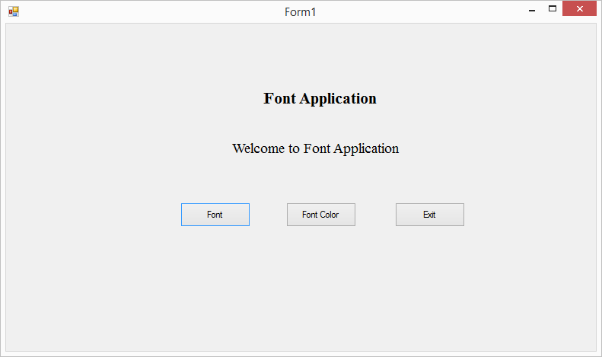

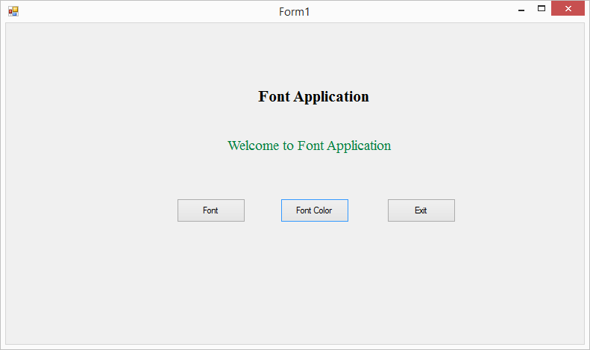

**CALCULATOR**

**PROGRAM CODING:**

Public Class Form1

Dim firstnumber As Long

Dim operation As String

Private Sub Button1_Click(sender As Object, e As EventArgs) Handles Button1.Click

If TextBox1.Text = "0" Then

TextBox1.Text = "1"

Else

TextBox1.Text = TextBox1.Text & "1"

End If

End Sub

Private Sub Button2_Click(sender As Object, e As EventArgs) Handles Button2.Click

If TextBox1.Text = "0" Then

TextBox1.Text = "2"

Else

TextBox1.Text = TextBox1.Text & "2"

End If

End Sub

Private Sub Button3_Click(sender As Object, e As EventArgs) Handles Button3.Click

If TextBox1.Text = "0" Then

TextBox1.Text = "3"

Else

TextBox1.Text = TextBox1.Text & "3"

End If

End Sub

Private Sub Button4_Click(sender As Object, e As EventArgs) Handles Button4.Click

If TextBox1.Text = "0" Then

TextBox1.Text = "4"

Else

TextBox1.Text = TextBox1.Text & "4"

End If

End Sub

Private Sub Button5_Click(sender As Object, e As EventArgs) Handles Button5.Click

If TextBox1.Text = "0" Then

TextBox1.Text = "5"

Else

TextBox1.Text = TextBox1.Text & "5"

End If

End Sub

Private Sub Button6_Click(sender As Object, e As EventArgs) Handles Button6.Click

If TextBox1.Text = "0" Then

TextBox1.Text = "6"

Else

TextBox1.Text = TextBox1.Text & "6"

End If

End Sub

Private Sub Button7_Click(sender As Object, e As EventArgs) Handles Button7.Click

If TextBox1.Text = "0" Then

TextBox1.Text = "7"

Else

TextBox1.Text = TextBox1.Text & "7"

End If

End Sub

Private Sub Button8_Click(sender As Object, e As EventArgs) Handles Button8.Click

If TextBox1.Text = "0" Then

TextBox1.Text = "8"

Else

TextBox1.Text = TextBox1.Text & "8"

End If

End Sub

Private Sub Button9_Click(sender As Object, e As EventArgs) Handles Button9.Click

If TextBox1.Text = "0" Then

TextBox1.Text = "9"

Else

TextBox1.Text = TextBox1.Text & "9"

End If

End Sub

Private Sub Button14_Click(sender As Object, e As EventArgs) Handles Button14.Click

Dim secondnumber As Long

Dim result As Long

secondnumber = TextBox1.Text

If operation = "+" Then

result = firstnumber + secondnumber

ElseIf operation = "-" Then

result = firstnumber - secondnumber

ElseIf operation = "*" Then

result = firstnumber * secondnumber

ElseIf operation = "/" Then

result = firstnumber / secondnumber

End If

firstnumber = result

TextBox1.Text = result

End Sub

Private Sub Button10_Click(sender As Object, e As EventArgs) Handles Button10.Click

firstnumber = TextBox1.Text

TextBox1.Text = ""

operation = "+"

End Sub

Private Sub Button11_Click(sender As Object, e As EventArgs) Handles Button11.Click

firstnumber = TextBox1.Text

TextBox1.Text = ""

operation = "-"

End Sub

Private Sub Button12_Click(sender As Object, e As EventArgs) Handles Button12.Click

firstnumber = TextBox1.Text

TextBox1.Text = ""

operation = "*"

End Sub

Private Sub Button16_Click(sender As Object, e As EventArgs) Handles Button16.Click

firstnumber = TextBox1.Text

TextBox1.Text = ""

operation = "/"

End Sub

Private Sub Button15_Click(sender As Object, e As EventArgs) Handles Button15.Click

If TextBox1.Text = "0" Then

TextBox1.Text = "0"

Else

TextBox1.Text = TextBox1.Text & "0"

End If

End Sub

Private Sub Button13_Click(sender As Object, e As EventArgs) Handles Button13.Click

TextBox1.Text = ""

End Sub

End Class

**OUTPUT:**

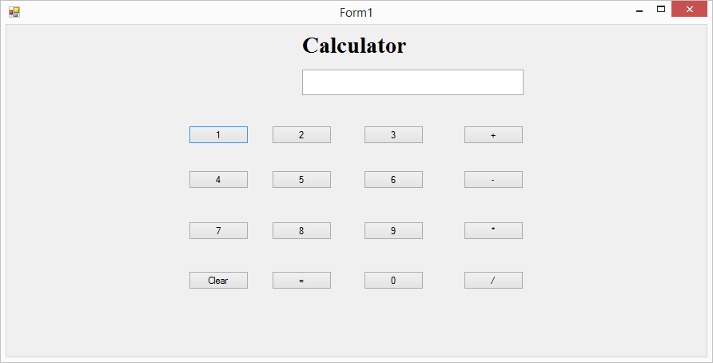

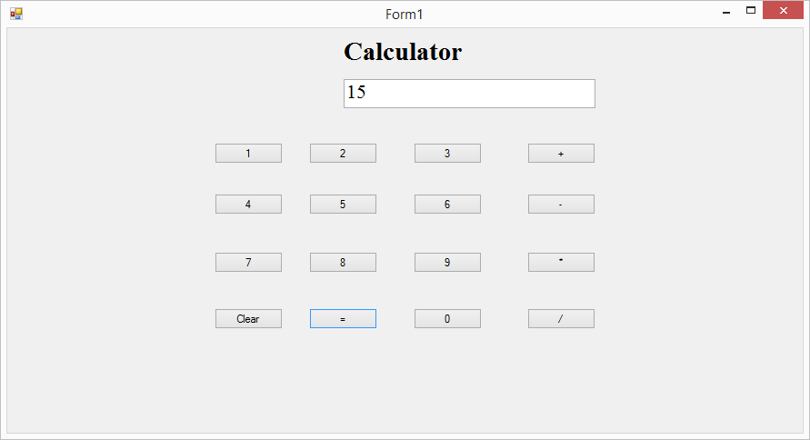

**NOTEPAD APPLICATIONS**

**PROGRAM CODING:**

Public Class Form1

Inherits System.Windows.Forms.Form

Dim pgset As New PageSetupDialog

Dim opdg As New OpenFileDialog

Dim sdg As New SaveFileDialog

Dim pd As New PrintDialog

Dim flgsave As Integer

Dim fndtxt As String

Dim rpltxt As String

Dim fd As New FontDialog

Dim rtd As New RichTextBox

Private Sub NewToolStripMenuItem_Click(sender As Object, e As EventArgs) Handles NewToolStripMenuItem.Click

RichTextBox1.Text = ""

RichTextBox1.Focus()

Form.ActiveForm.Text = ""

Me.Text = "Untitled-notepad"

flgsave = 0

End Sub

Private Sub OpenToolStripMenuItem_Click(sender As Object, e As EventArgs) Handles OpenToolStripMenuItem.Click

opdg.ShowDialog()

Me.RichTextBox1.LoadFile(opdg.FileName, RichTextBoxStreamType.PlainText)

End Sub

Private Sub SaveToolStripMenuItem_Click(sender As Object, e As EventArgs) Handles SaveToolStripMenuItem.Click

sdg.DefaultExt = "*.txt"

sdg.Filter = "Text Files|*.txt"

If (sdg.ShowDialog() = System.Windows.Forms.DialogResult.OK) _

And (sdg.FileName.Length) > 0 Then

RichTextBox1.SaveFile(sdg.FileName, RichTextBoxStreamType.PlainText)

End If

End Sub

Private Sub PagesToolStripMenuItem_Click(sender As Object, e As EventArgs) Handles PagesToolStripMenuItem.Click

PrintDocument1.DocumentName = RichTextBox1.Text

pgset.Document = PrintDocument1

pd.ShowDialog()

End Sub

Private Sub PrintToolStripMenuItem_Click(sender As Object, e As EventArgs) Handles PrintToolStripMenuItem.Click

PrintDocument1.DocumentName = RichTextBox1.Text

pd.Document = PrintDocument1

pd.ShowDialog()

End Sub

Private Sub ExitToolStripMenuItem_Click(sender As Object, e As EventArgs) Handles ExitToolStripMenuItem.Click

Close()

End Sub

Private Sub CutToolStripMenuItem_Click(sender As Object, e As EventArgs) Handles CutToolStripMenuItem.Click

RichTextBox1.Cut()

End Sub

Private Sub CopyToolStripMenuItem_Click(sender As Object, e As EventArgs) Handles CopyToolStripMenuItem.Click

RichTextBox1.Copy()

End Sub

Private Sub PasteToolStripMenuItem_Click(sender As Object, e As EventArgs) Handles PasteToolStripMenuItem.Click

RichTextBox1.Paste()

End Sub

Private Sub DeleteToolStripMenuItem_Click(sender As Object, e As EventArgs) Handles DeleteToolStripMenuItem.Click

RichTextBox1.SelectedText = ""

End Sub

Private Sub FindToolStripMenuItem_Click(sender As Object, e As EventArgs) Handles FindToolStripMenuItem.Click

fndtxt = InputBox("Find What?", "FIND")

RichTextBox1.Find(fndtxt, 0)

End Sub

Private Sub ReplaceToolStripMenuItem_Click(sender As Object, e As EventArgs) Handles ReplaceToolStripMenuItem.Click

fndtxt = InputBox("Find What?", "FIND")

rpltxt = InputBox("Replace With", "Replace")

RichTextBox1.Find(fndtxt, 0)

RichTextBox1.SelectedText = rpltxt

End Sub

Private Sub SelectAllToolStripMenuItem_Click(sender As Object, e As EventArgs) Handles SelectAllToolStripMenuItem.Click

RichTextBox1.SelectAll()

End Sub

Private Sub UndoToolStripMenuItem_Click(sender As Object, e As EventArgs) Handles UndoToolStripMenuItem.Click

RichTextBox1.Undo()

End Sub

Private Sub DateToolStripMenuItem_Click(sender As Object, e As EventArgs) Handles DateToolStripMenuItem.Click

RichTextBox1.SelectedText = Now

End Sub

Private Sub WordToolStripMenuItem_Click(sender As Object, e As EventArgs) Handles WordToolStripMenuItem.Click

If WordToolStripMenuItem.Checked = False Then

WordToolStripMenuItem.Checked = True

Else

RichTextBox1.WordWrap = True

End If

End Sub

Private Sub FormatToolStripMenuItem1_Click(sender As Object, e As EventArgs) Handles FormatToolStripMenuItem1.Click

fd.ShowDialog()

RichTextBox1.Font = fd.Font

End Sub

End Class

**OUTPUT:**

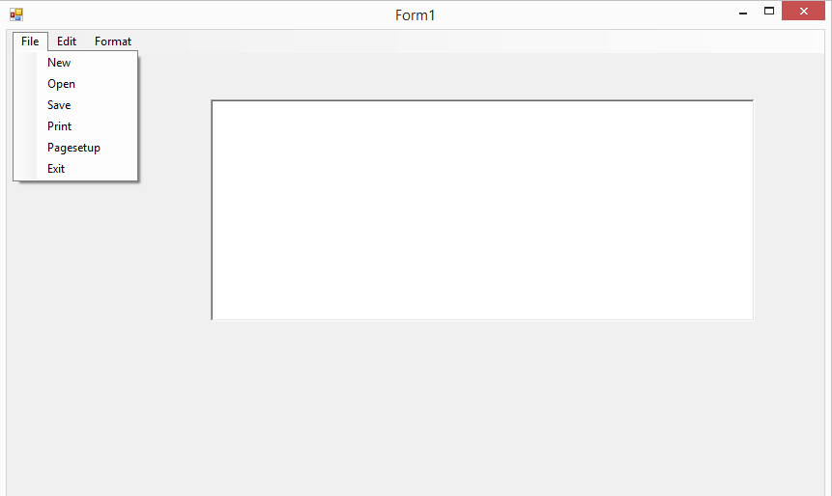

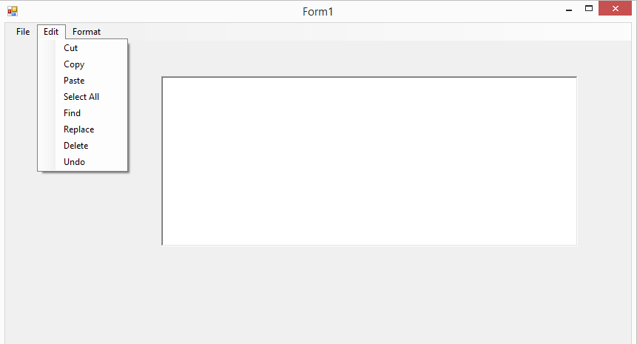

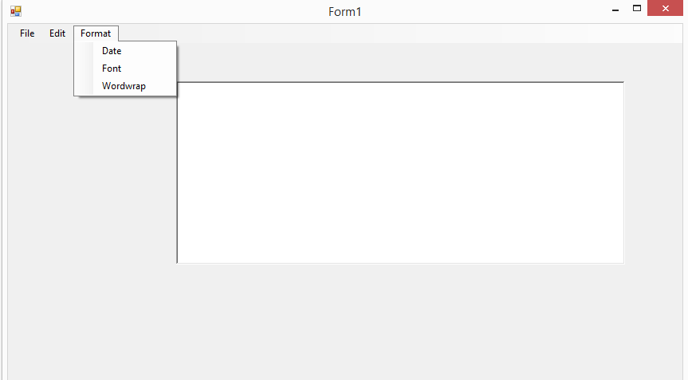

**TEXT FILE CREATION**

**PROGRAM CODING:**

Public Class Form1

Dim opentxt As New OpenFileDialog

Dim savetxt As New SaveFileDialog

Private Sub Button1_Click(sender As Object, e As EventArgs) Handles Button1.Click

RichTextBox1.Text = ""

End Sub

Private Sub Button2_Click(sender As Object, e As EventArgs) Handles Button2.Click

Opentxt.Filter = "Text(*.txt)|*.txt|rft(plaintext)|*.rtf"

Opentxt.ShowDialog()

If Opentxt.FileName = "" Then

Else

Dim open As New IO.StreamReader(Opentxt.FileName)

RichTextBox1.Text = open.ReadToEnd

End If

End Sub

Private Sub Button3_Click(sender As Object, e As EventArgs) Handles Button3.Click

savetxt.Filter = "Text(*.txt)|*.txt|rft(plaintext)|*.rtf"

savetxt.ShowDialog()

MsgBox(savetxt.FileName)

If savetxt.FileName = "" Then

MsgBox("Error: path not found", MsgBoxStyle.Critical, "Error")

Else

Dim save As New IO.StreamWriter(savetxt.FileName)

save.Write(RichTextBox1.Text)

save.Close()

End If

End Sub

Private Sub Button4_Click(sender As Object, e As EventArgs) Handles Button4.Click

Close()

End Sub

End Class

**OUTPUT:**

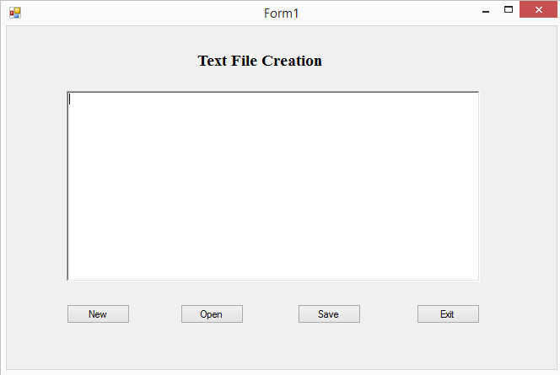 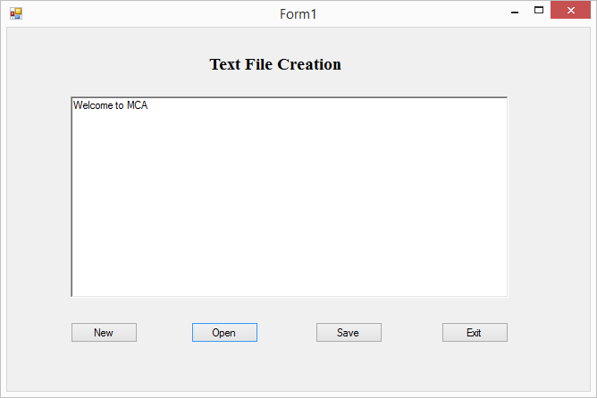

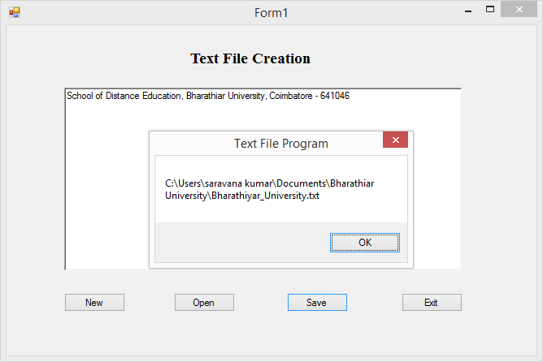

**NEWSPAPER VENDOR DETAILS**

**PROGRAM CODING:**

**Form 1:**

Public Class Form1

Inherits System.Windows.Forms.Form

Private Sub Button1_Click(sender As Object, e As EventArgs) Handles Button1.Click

Form2.Show()

End Sub

Private Sub Button2_Click(sender As Object, e As EventArgs) Handles Button2.Click

End

End Sub

End Class

**Form 2:**

Imports System.Data.OleDb

Public Class Form2

Inherits System.Windows.Forms.Form

Dim cmd As OleDbCommand

Dim dread As OleDbDataReader

Dim pc, pn, sql As String

Dim pr, co As Double

Dim con As New OleDbConnection("Provider=Microsoft.Jet.OLEDB.4.0; Data Source=E:\npaper.mdb")

Sub movedata()

pc = Val(TextBox1.Text)

pn = ComboBox1.Text

pr = Val(TextBox2.Text)

co = Val(TextBox3.Text)

End Sub

Sub displaydata()

TextBox1.Text = dread(0)

ComboBox1.Text = dread(1)

TextBox2.Text = dread(2)

TextBox3.Text = dread(3)

End Sub

Sub Clearfields()

TextBox1.Text = ""

ComboBox1.Text = ""

TextBox2.Text = ""

TextBox3.Text = ""

End Sub

Private Sub Button1_Click(sender As Object, e As EventArgs) Handles Button1.Click

movedata()

con.Open()

sql = "insert into npaper values (" & pc & ", '" & pn & "', " & pr & "," & co & ")"

cmd = New OleDbCommand(sql, con)

cmd.ExecuteNonQuery()

con.Close()

MsgBox("The given paper details are stored", MsgBoxStyle.Information, "Save")

Clearfields()

End Sub

Private Sub Button2_Click(sender As Object, e As EventArgs) Handles Button2.Click

movedata()

con.Open()

sql = "update npaper set pn = '" & pn & "', pr = " & pr & ", co = " & co & " where pc = " & pc & ""

cmd = New OleDbCommand(sql, con)

cmd.ExecuteNonQuery()

con.Close()

MsgBox("The given paper detail is modified", MsgBoxStyle.Information, "Modified")

Clearfields()

End Sub

Private Sub Button3_Click(sender As Object, e As EventArgs) Handles Button3.Click

con.Open()

sql = "Delete from npaper where pc =" & TextBox1.Text & ""

cmd = New OleDbCommand(sql, con)

cmd.ExecuteNonQuery()

con.Close()

MsgBox("The given detail is deleted", MsgBoxStyle.Information, "Delete")

Clearfields()

End Sub

Private Sub Button4_Click(sender As Object, e As EventArgs) Handles Button4.Click

Me.Dispose()

End Sub

Private Sub TextBox1_Leave(sender As Object, e As EventArgs) Handles TextBox1.Leave

sql = "select * from npaper where pc = " & Val(TextBox1.Text) & ""

con.Open()

cmd = New OleDbCommand(sql, con)

dread = cmd.ExecuteReader

If dread.HasRows = True Then

dread.Read()

displaydata()

End If

dread.Close()

con.Close()

End Sub

Private Sub TextBox1_Enter(sender As Object, e As EventArgs) Handles TextBox1.Enter

Clearfields()

End Sub

End Class

**OUTPUT:**

**Form 1:**

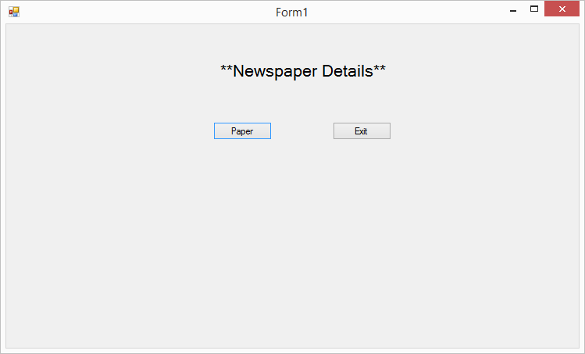

**Form 2:**

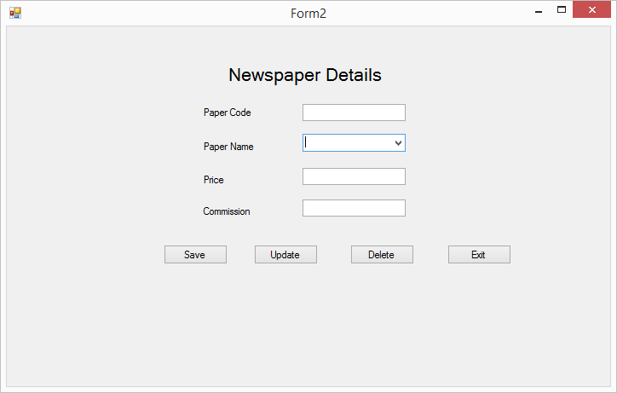

**Database View:**

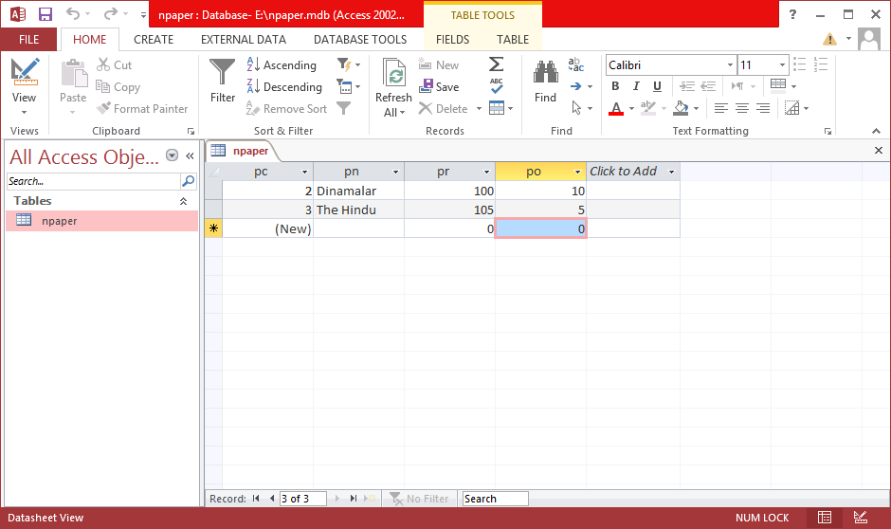

**Existing Data:**

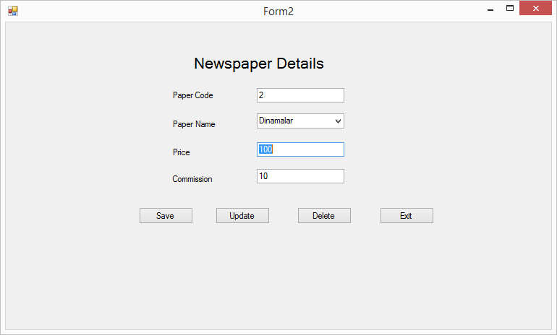

**Save**

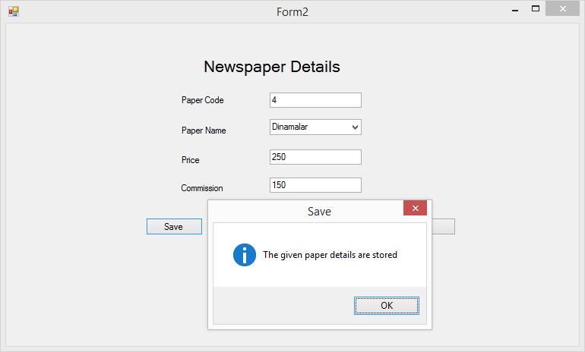

**Delete**

